MAVEN LIFE CYCLE

Step 1: create a project in IntelliJ

Step 2: fill the group id, Artifact id, Version and click on the create button

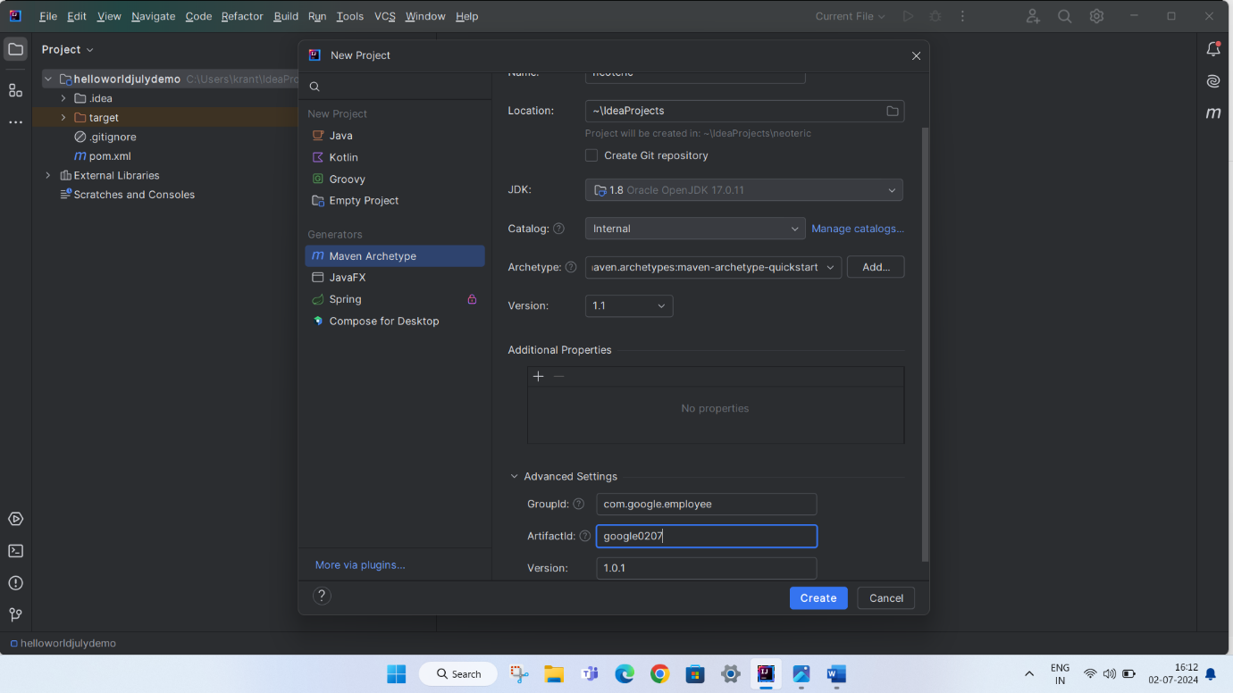

Step 3: click on the clean option to clear old running history

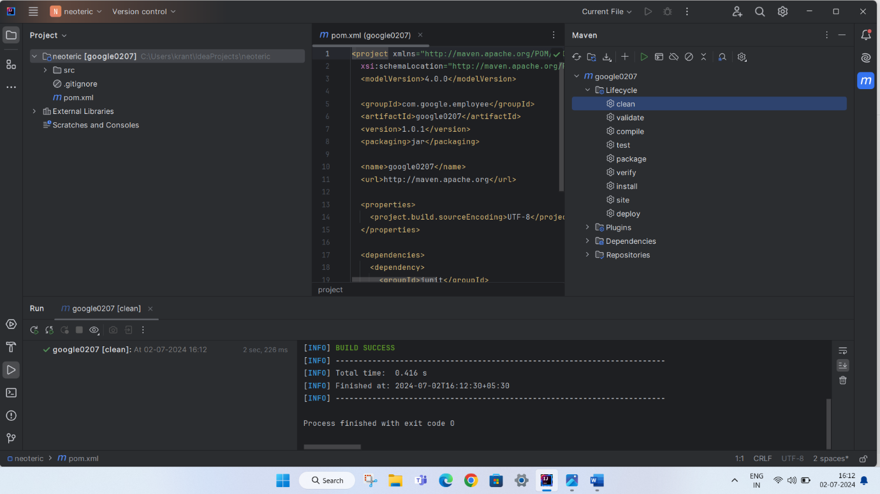

Step 4: Click on option package to specifies the type of Artifact produces by your project that only happened in workspace

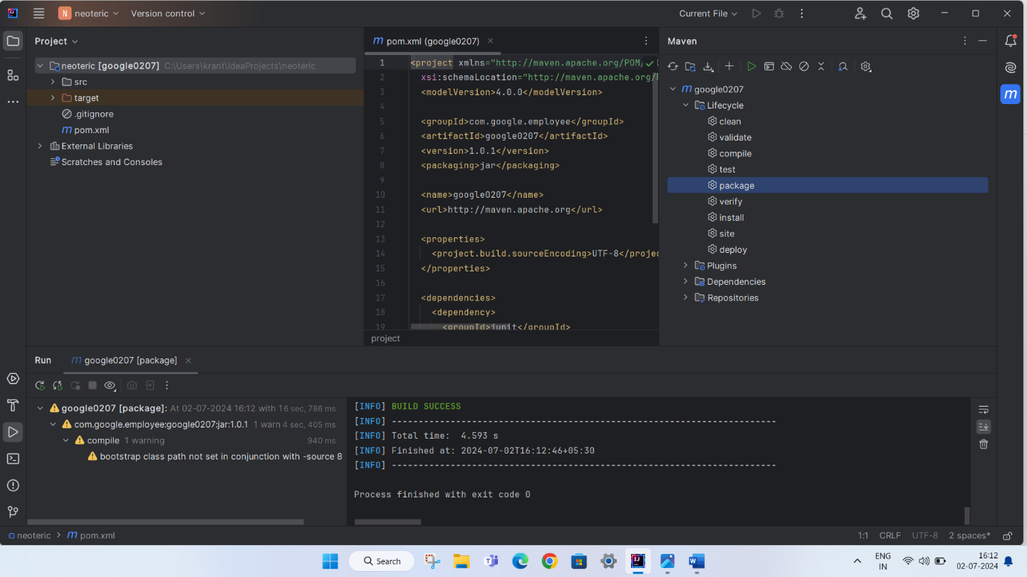

Step 5: Select the option install to install the .jar file in local repository under .m2 folder

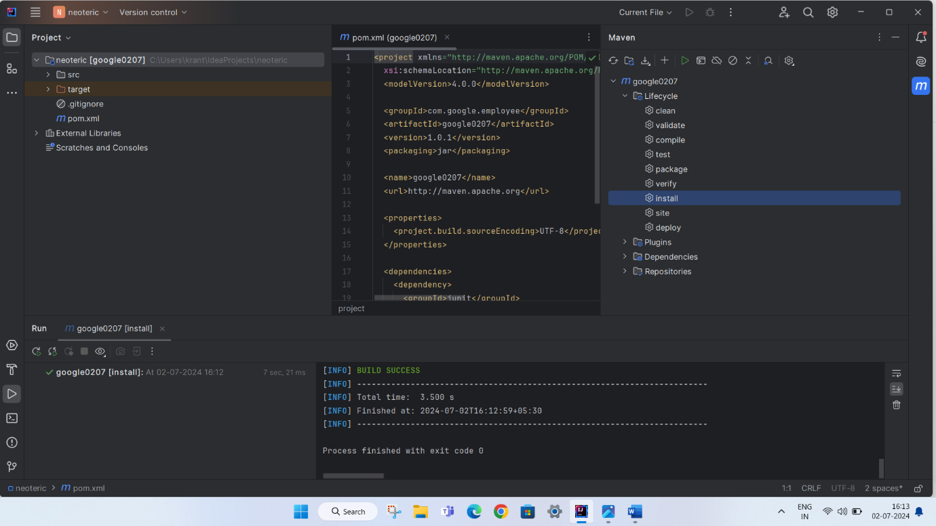

Step 6: Here we can see from the above image path is changed from target folder to .m2 folder

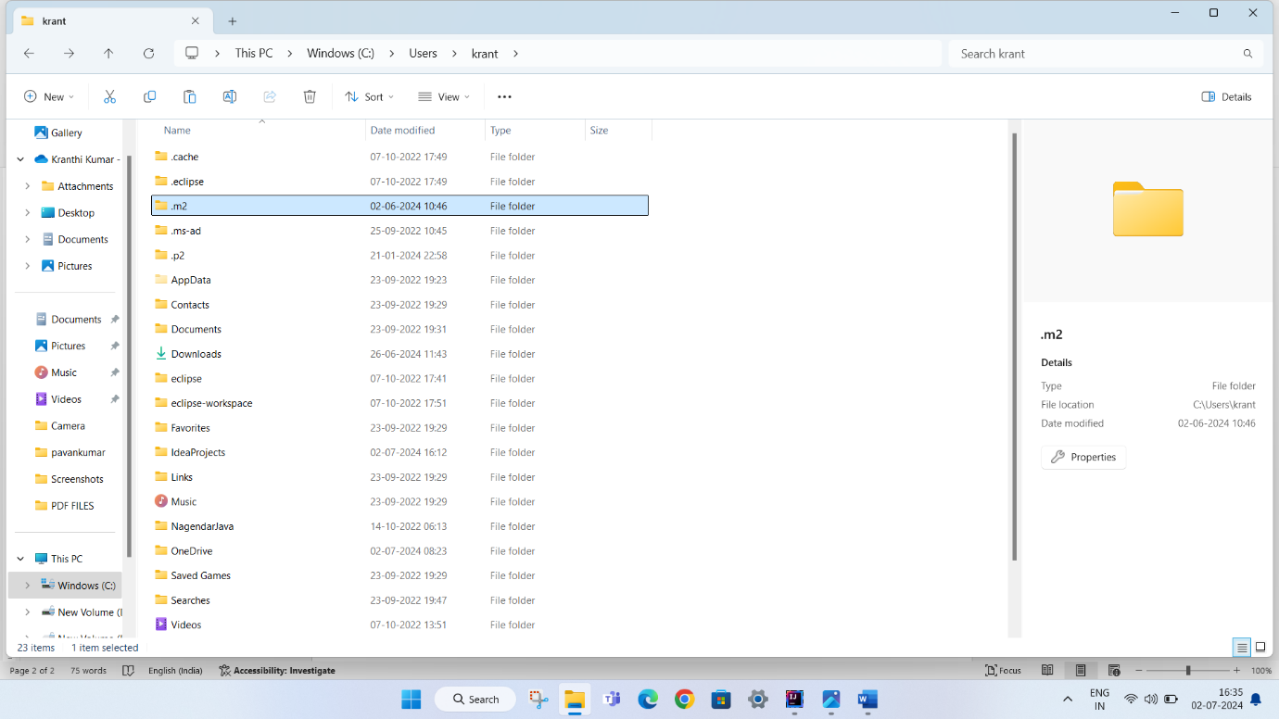

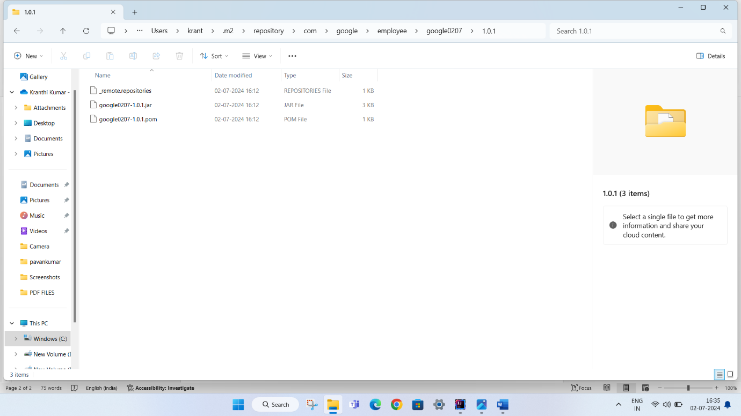

Here the path is

.m2 folder

↓

Repository

↓

Com (group id)

Google (group id)

↓

Employee (group id)

↓

Google 0207 (artifact id )

↓

Version (1.0.1)

↓

.jar folder